Monastery of Our Lady of Hyning

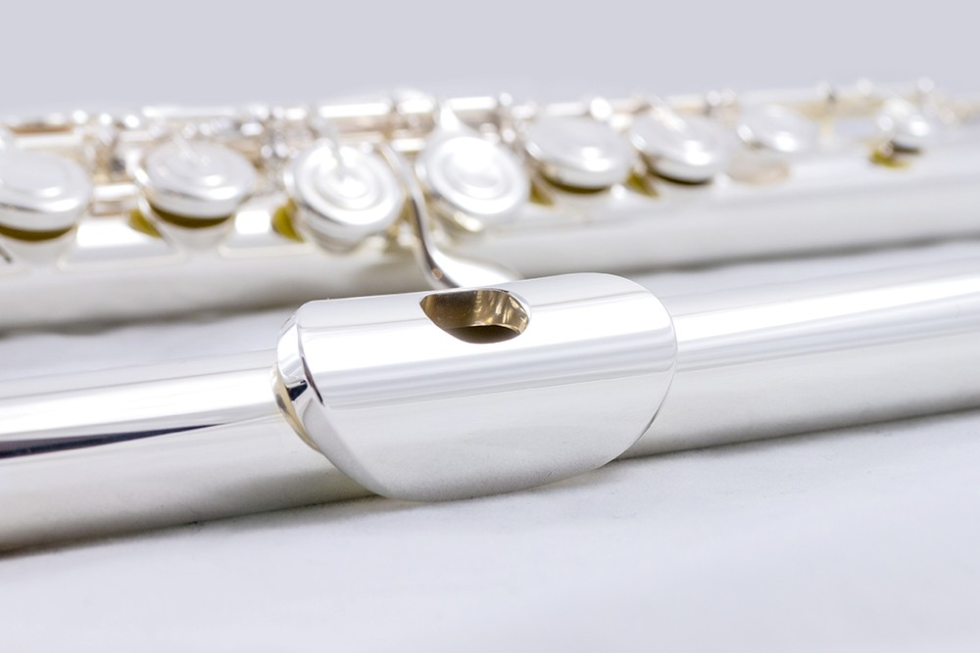

Ecumenical Flute Retreat
1st – 5th October 2024

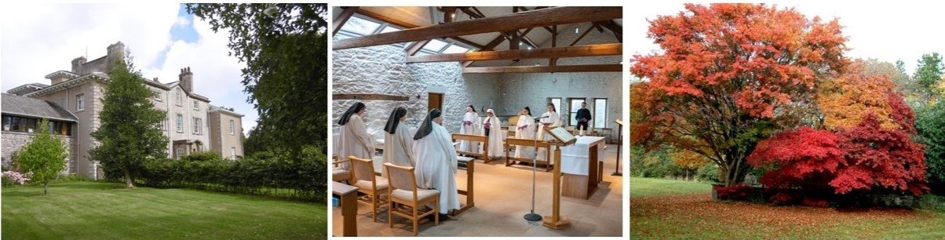

An Ecumenical Flute Retreat
Tuesday 1st October (5.30 pm) to Saturday 5th October (2 pm) 2024
Following the success of the inaugural Hyning Monastery Flute Retreat which took place in June 2023, flautists are again invited to take part in a retreat which combines elements of a classical spiritual retreat - conferences, time for personal and community prayer – with an opportunity to explore how music can be a path to God. There will be plenty of time to enjoy playing in a group, as a solo player and during the liturgy.
It is particularly suitable for those who use their flute within Christian worship or for flautists who would like to combine the spiritual and musical dimensions of a flute retreat. Each one can work out his or her own balance between the two dimensions.
All abilities of flute playing are welcome, though realistically, about a grade 4 minimum level will be helpful. It is not suitable for complete beginners.
The Spiritual Dimension
Participants are very welcome to share in all or some of the daily prayer of the Bernardine Community at Hyning and the Eucharist. The community is Roman Catholic but all Christian denominations are welcome and we hope all will feel at home with the largely scripture-based liturgy.
At some of the services there will be the opportunity to play during the liturgy.
There will be a spiritual conference each day and participants are welcome to profit from the silent chapel and beautiful grounds for personal prayer.
The Musical Dimension
Every day the group will prepare a suitable ensemble piece to play after Vespers. Each participant is also encouraged to bring a piece to work on during the week. In addition, there will be time for playing duos and trios. We will also look at what sort of music is appropriate for use in Christian worship.
Whilst there will be plenty of music, the emphasis will not be on technical development.
A Relaxing Dimension
The Monastery of Our Lady of Hyning is in an area of outstanding natural beauty close to Morecambe Bay and not far from the Lake District. Beyond its own landscaped garden, glowing with autumn colours, there are many beautiful walks to be enjoyed during the free afternoons.
The Guest House has 12 very comfortable en-suite bedrooms and a further five rooms in an adjacent cottage. Much of the food is home grown and coffee and tea-making facilities are available. It is an ideal place to have a break from the busyness of ordinary life and to enjoy playing your flute and connecting with God.
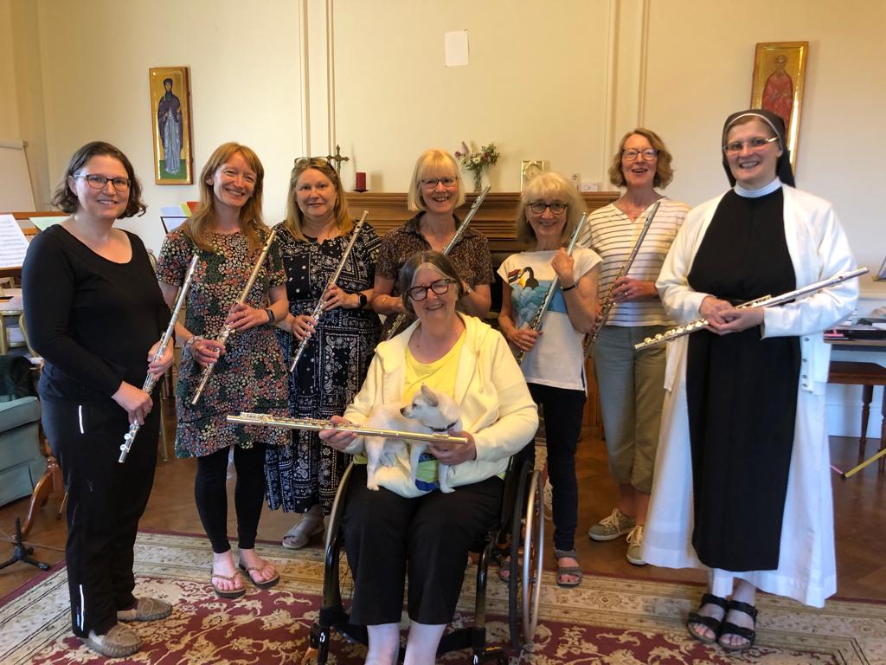
x
Photos of the retreat 2023
Morning rehearsal session
Relaxing in the afternoon discovering the local area.

The Retreat Organiser
The Retreat Organisers
Sr Mary Helen is a Bernardine Sister at the Monastery or Our Lady of Hyning and a passionate amateur flautist. She holds the ARSM diploma and the ACertCM (Archbishops’ Certificate of Church Music.) She also plays keyboard. She frequently uses her flute within the Christian liturgy and would love to welcome other flautists to Hyning to share her joy in playing the flute for the Lord!
She will be joined each day by Liz Gilbert, a local flute teacher who will conduct the ensemble practices. Liz has long experience of working with diverse music groups.

Practical Details
Cost : Suggested donation : full board accommodation £240
retreat fee : £130 (total £370) Non-refundable deposit of £30

(Non-playing family and friends sharing a room are also welcome - £240)

The retreat starts at 5.30 pm on Tuesday 1st October (arrivals any time during the afternoon) and ends after lunch on Saturday 5th October.

Further information and enrolment
For further details or any questions, please contact Sr Mary Helen at sistermaryhelen@hotmail.com or telephone 01524 732684.

Information about Hyning can be found on the website www.hyning.org

12 playing places are available. We look forward to welcoming you!!

Hyning is 2 miles from Carnforth Station which has regular trains to the mainline stations of Lancaster, Preston and Manchester airport.
Local walking

MONASTERY OF OUR LADY OF HYNING
Warton, Carnforth, Lancashire, LA5 9SE

